Reintroduction to your breath
If you have difficulty relaxing lie in the relaxed position and focus on your breathing pattern.
Gently breathe in and hold your breath for a few seconds after inhalation. Upon exhalation restrict the air flow by using your lips, teeth or tongue to lengthen the exhalation. It is beneficial to make a whizzing sound as the air flows out because the air flow becomes audible. In this way the sound will reveal whether the air flow is slow and continuous or if it is interrupted and uneven due to tension.
Remember this: “The key to relaxation is in the exhalation” During exhalation focus on relaxing your diaphragm (belly) and shoulders.
Hold & Release - Create tension to emphasize the difference between tension and relaxation.
Go through a few breathing cycles where you make a forceful inhalation while clenching your fists, arms, face and contract almost every muscle in your body. Hold this tension for a couple of seconds. Relax upon exhalation. Repeat the breathing cycle 3-4 times as tolerated.
SMILE - smiling influences your trigeminal nerve causing a release of endorphins in your body and boosts your immunity and at the same time decreases the level of stress hormones (adrenalin and cortisol) and lowers your blood pressure. This helps you feel happy, relaxed and at ease.

Everyday functional breath
Breathe like the waves in the ocean – soft and easy “in to your belly”
When you use the diaphragm the abdominal organs are massaged. The diaphragm directly massages some very central organs: liver, pancreas, spleen, stomach and kidneys. But also the small and large intestines are massaged by its action. When you perform exercises that involve the diaphragm it is not unusual to feel this direct impact on the organs and this is why the stomach should be empty when breathing exercises are performed. The moving diaphragm will increase blood flow to these organs and the mixing of fluids.
Practicing the diaphragmatic breath increases attention and focus to details in the breathing process. A functional breath is slow and deep diaphragmatic breathing through the nose. In diaphragmatic breathing the inhaled air moves deep down into the lungs making the low part of the belly rise first and ending with the breast expanding.
Think of filling up a water bottle – from the bottom smooth to the top
The result is like a wave moving from the pubic bone up into the thorax and ending with the lungs about 80% filled. Inhalation and exhalation should be through the nose to slow the flow and control it better.

- If sitting, imagine a piece of string gently pulling you upwards towards the ceiling.
- Imagine and feel the space around your ribs widening. 360 degrees all the way around like every mammal on the planet including us until we learnt bad habits.
- Place your hands on your chest and your belly above your naval

Restore the before(B4). Breathe first.
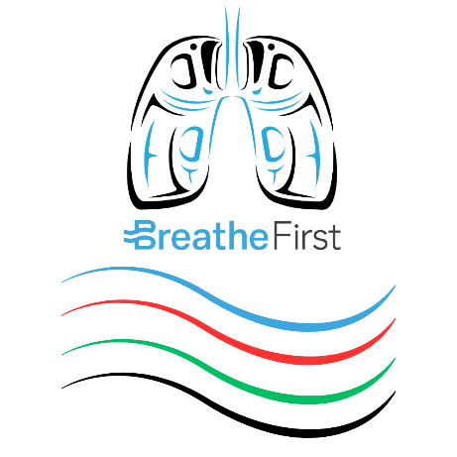
Breath + Body + Brain + Being

C02 Tolerance Training – Less is More!
- If sitting imagine a piece of string gently pulling you upwards towards the ceiling
- Imagine and feel the space between your ribs widening
- Utilize 360 degrees of your midsection – breathe horizontally
- With mouth closed and jaws relaxed breathe in and out through your nose.
- Place your hands on your chest and tummy or on your lap.
- Focus on the air flow as it moves in and out of your nose. Feel the slightly colder air entering your nose and feel the slightly warmer air leaving your nose.
- When you are able to follow your breathing take a short slow breath in through the nose and allow a gentle relaxed breath out.
- Breathe 80% of your normal breath in a slow and gentle manner. Breathing should be light, quiet and still.
- DO NOT consciously interfere with your breathing muscles or restrict your breathing during this exercise. DO NOT tense your stomach to reduce your breathing.
- The goal is to feel a want or a hunger for air. To have a feeling that you would like to take a bigger breath.

Contact:
BreatheFirst Program Director - Tyler Huston
250-667-7722
tyler@breathcontrol.ca
www.BreathControl.ca

